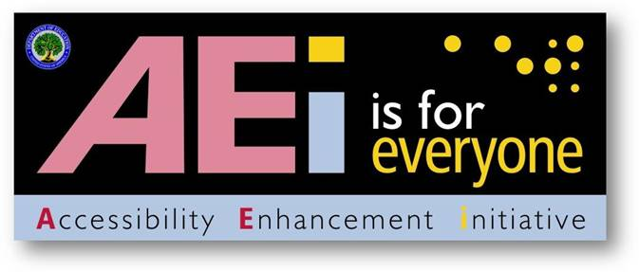

DRAFT
US Department of Education

Key Concepts for Creating Accessible Documents

June 2011

Key Concepts for Creating Accessible Documents

Listed below are basic concepts that help make documents accessible. The majority of these concepts provide an underlying technical structure so that they can be used effectively by assistive technology. When you create an accessible document, you are using methods that make a document usable by individuals with any type of disability. These concepts come from Section 508 requirements.
Assistive technology is used by individuals to help them understand electronic information. For example, screen readers or text-to-speech software is one tool available and assists individuals who are blind, have low vision, or a learning disability. This special technology interprets words on the page and translates them to a computerized voice that reads the information. You may have heard the name JAWS or Window-Eyes as these are some examples of this assistive technology. Accessible documents work in partnership with assistive technology to ensure individuals with disabilities have access to information.

DO:

Do use built-in features of an application (Word, Excel, etc.) to encode a structure and layout that can be used by assistive technology.

Documents should be created using built-in formatting styles (i.e., headings, subheadings, slide layouts, headers/footers, tables, columns etc.) to create the underlying technical structure that allows assistive technology to work properly. The use of these built-in features will allow individuals using assistive technology to navigate through documents more quickly and efficiently to move from section to section. Without such structural formatting, a multiple page document would be read by a screen-reader as a big block of text, and a user would have to read through all of the text to locate a specific section.

Do create a structure that allows assistive technology to read the content in a logical order.
It is important that information be structured in such a way that assistive technology can read it in a logical order. There are instances where graphic design components affect the underlying structure and cause the assistive technology to read sections of the document out-of-order. This is not acceptable because it presents the material to the individual in an incomprehensible manner.

An Example of an Inaccessible Logical Order

Every child is an artist. The problem is If anything can go wrong, it will –to how how to remain an artist once we grow up. at the worst possible time.
-Pablo Picasso -Murphy's Law

In this example, a screen reader reads: "Every child is an artist. The problem is If anything can go wrong, it will – at the how to remain an artist once we grow up. worst possible time. Pablo Picasso Murphy's Law" because tabs were used to create the page design.

An Example of an Accessible Logical Order

Every child is an artist. The problem is how to remain an artist once we grow up.
-Pablo Picasso
If anything can go wrong, it will - at the worst possible time.
- Murphy's Law

Although the example below looks the same as the one above, it is correctly structured in columns, so it is read in the correct order when reading it with a screen reader. In this example, a screen reader reads: "Every child is an artist. The problem is how to remain an artist once we grow up. - Pablo Picasso If anything can go wrong, it will-at the worst possible time. -Murphy's Law."

Do provide a text equivalent for every non-text element.

Documents are usually a combination of text and non-text elements. Non-text elements can be images, photos, charts, graphical text or audio files. Because a screen reader cannot read a non-text element, it is important to include text equivalents so that people using assistive technology have access to the graphical elements. Text equivalents are referred to as “alt text” or alternative text that describes the information in a non-text element.

Examples of Equivalent Text for a Non-Text Element

Example Figure 1:

Figure 2: City Schools Contract Committees Structures
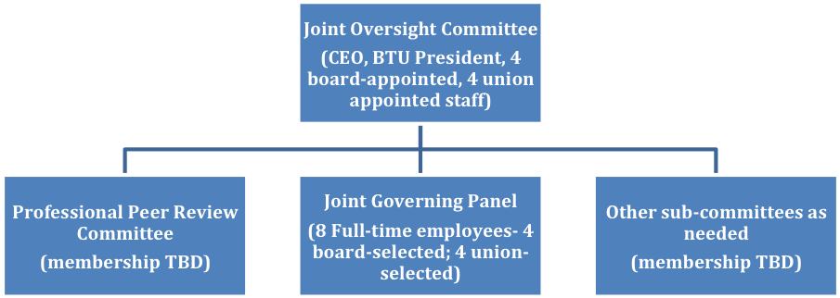

Example Figure 1 Alternative Text (Alt Text):

Figure 2 is titled City Schools Contract Committees Structures. This is an organizational chart with three boxes, on the same level, reporting to a top box. The top box contains Joint Oversight Committee (CEO, BTU President, 4 board-appointed, 4 union appointed staff). The first lower level box contains Professional Peer Review Committee (membership TBD). The second lower level box contains Joint Governing Panel (8 Full-time employees- 4 board-selected; 4 union-selected). The third lower level box contains Other sub-committees as needed (membership TBD).

Example Figure 2:
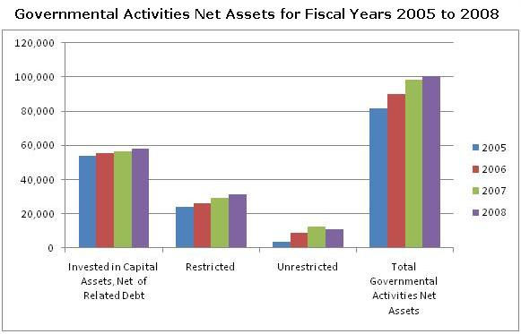

The table below shows the data for Governmental Activities Net Assets for Fiscal Years 2005 to 2008 in amounts in millions of dollars:

GOVERNMENTAL ACTIVITIES | 2005 | 2006 | 2007 | 2008
Invested in Capital Assets, Net of Related Debt | 53,815 | 55,473 | 56,438 | 58,208
Restricted | 24,110 | 25,993 | 29,347 | 31,358
Unrestricted | 3,753 | 8,696 | 12,565 | 11,105
Total Governmental Activities Net Assets | 81,678 | 90,162 | 98,350 | 100,671

Do synchronize multimedia presentations with equivalent alternatives.

Have you ever watched a television program where the sound was not synchronized and the actor’s movements didn’t match what you were hearing? It makes understanding the program more difficult because the combination of the actor’s voice and visual cues provides more meaning. Captions are text that replace spoken words and sounds for individuals who are deaf or hearing impaired. Audio descriptions allow individuals who are blind or have low vision to access visual content that is not otherwise accessible by listening to audio as narrators describe actions, gestures, scene changes, titles, speaker names or other visual information. It is important that the captions and audio descriptions are synchronized with the original presentation so that individuals with disabilities have access to the contextual meaning of the material.

Do use mark-up to keep row and column headers associated with the right data cells in data tables.

A data table is a grid that contains a set of related information in row and column format. A data table contains column and/or row headers. Visually, data tables are easy to understand because a sighted user can scan up to the top of the column or the beginning of the row to read the column and row headers for any data cell in the table. Individuals using a screen reader rely on the software to announce the column or row headers. Therefore, it is important to identify the headings in a table so that a screen reader will be able to clearly match which heading relates to a data cell. However, because of the constraints of current technology, only simple tables can be made accessible in Word and PowerPoint. More complex tables may be made accessible by conversion and remediation to PDF.

Figure 1: An example of an inaccessible table in Word and PowerPoint (not simple)
Dept Code | Class # | Section | Max Enrollment | Room # | Days | Instructor
BIO | 100 | 1 | 15 | 5 | Mon, Wed, Fri | Warren
BIO | 100 | 2 | 15 | 6 | Tue, Thu | Thomas
BUS | 150 | 1 | 15 | 13 | Mon, Wed, Fri | Halden
BUS | 210 | 1 | 10 | 13 | Mon, Wed, Fri | Jones

Figure 2: An example of an accessible table in Word or PowerPoint (simple)
Dept Code | Class # | Section | Max Enrollment | Room # | Days | Instructor
BIO | 100 | 1 | 15 | 5 | Mon, Wed, Fri | Warren
BIO | 100 | 2 | 15 | 6 | Tue, Thu | Thomas
BUS | 150 | 1 | 15 | 13 | Mon, Wed, Fri | Halden
BUS | 210 | 1 | 10 | 13 | Mon, Wed, Fri | Jones

Do use electronic forms that allow people using assistive technology to access information, field elements, and functionality including all directions and cues.

Forms are primarily used for collecting information. When forms are not designed for accessibility, individuals with disabilities will not be able to fill out the form. In order to ensure accessibility, forms must provide accessible labels for form fields and provide instructions and cues to help with form completion and submission; ensure that all navigation and interactivity within the form can be performed using the keyboard; provide a logical tab and reading order; ensure a visual focus is provided so that users know where they are in the
form and are able to interact with the controls, and provide accessible error messages.

Do create interactive documents (i.e., forms, links) that are functional using a keyboard.

Some individuals with disabilities are not able to use a mouse. Therefore, all documents
containing an interactive component must be fully functional using the keyboard or another
assistive technology device to navigate through documents. Additionally, document with
interactive components must contain an on-screen focus (cursor) so that users can locate the
current position within the document.

Do provide an alternative format, with equivalent information and functionality, if a document cannot be made accessible. This option should be used as a last resort.

Documents must be accessible; however, there are some instances where remediation is not possible and production of an alternative format is necessary. In these instances, you must:
1) get guidance from the Accessibility Team 2) have the inaccessible document make reference to the alternative version and 3) ensure the alternative version is accessible.

DO NOT:

Do not use blinking text, objects, or other elements having a flash or blink frequency greater than 2 Hz and lower than 55 Hz.

Blinking text, objects, or other elements that have a flash or blinking frequency in this range may cause seizures in individuals with photosensitive epilepsy and may be distracting to individuals with learning disabilities. Therefore, these frequencies should not be used.

- Do not use color-coding as the only means of conveying information or distinguishing a visual element.
Color is useful in conveying important information. However, when color alone is used to convey meaning (i.e., making a section of text red), then a person who is blind or colorblind will not have access to the information. Therefore, color alone will not make information accessible. A remedy would be to use color and another indicator.

An Example of using color and another indicator
Below is a list of participants with the winner denoted with * and highlighted in
red.
Ann Jones
Jim Cane*
Janis Poole

If you have any questions about this document or the Accessibility Enhancement Initiative, please call Holly Anderson at 202.453.6380 or Holly.Anderson@ed.gov.

